**Special Issue on AI-Driven Real-Time Distributed Computing for the Edge-Cloud Continuum**

<https://www.sciencedirect.com/special-issue/317877/ai-driven-real-time-distributed-computing-for-the-edge-cloud-continuum>

**Submission deadline: 30 October 2025**

**Scope and topics**

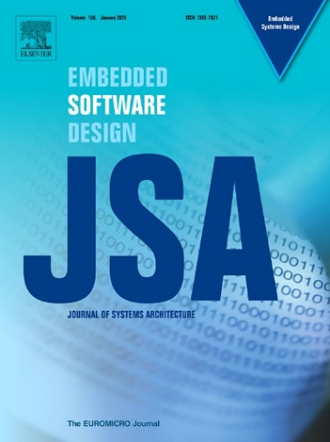This special issue solicits high-quality papers pertaining to all aspects of objects, components, service-oriented real-time and distributed computing technology that address the growing challenges of real-time distributed computing, particularly through case studies and applications that demonstrate the efficacy of proposed methods in real-world distributed systems, to meet the demands of next-generation edge AI-enabled IoT applications such as autonomous vehicles, smart cities, intelligent transportation systems, industrial automation systems and industry 4.0, smart grids, avionics, spatial, under-water, autonomous vehicles, consumer electronics, multimedia processing, etc. with an emphasis on scalability, security, and integration with modern technologies. The specific SI focus areas include, but are not limited to:

* Distributed and/or Real-Time Image, video, and Stream Processing
* Emerging Next-Gen Software-Defined Embedded Systems and Networks
* Federated Learning, TinyML, Edge ML, Generative AI, and Fog Computing
* Real-Time Data Analytics, Management, and Monitoring
* Middleware, Cloud Connectivity, and Microservices
* DevOps for Distributed Real-time Computing
* Optimization Algorithms, metaheuristics, and graphs for Edge-Cloud continuum
* Sustainable and Green Computing Transformation
* Formal Methods, Verification, and Model Checking
* Ontology-based Knowledge Modeling
* Dependability, Fault tolerance, and Resilience
* AI/ML Algorithms for Real-Time Analytics
* Operating Systems, Middleware, and System software and Software architectures
* Blockchain and Security Enhancements
* Digital Twins for Distributed and/or Real-Time IoT Systems and Applications

### **Manuscript Submission Instructions**

Prospective authors should submit their manuscripts following The Journal of Systems Architecture (JSA) guidelines. Details can be found at: [Guide for authors - Journal of Systems Architecture](https://www.sciencedirect.com/journal/journal-of-systems-architecture/publish/guide-for-authors).

Solicited original submissions must not be currently under consideration for publication in other venues. All manuscripts and any supplementary material should be submitted through the Submission [site for Journal of Systems Architecture](https://www.editorialmanager.com/jsa/). Please select the “**VSI:AI4ORC**” option as article type of the paper.

All submissions deemed suitable by the editors to be sent for peer review will be reviewed by at least two independent reviewers. Once your manuscript is accepted, it will go into production to be published in the special issue.

### **The special issue anticipates receiving extended papers from the IEEE ISORC 2025 conference**.

### **Guest Editors**

**Daniel Casini**

Scuola Superiore Sant'Anna

Pisa, Italy

[daniel.casini@santannapisa.it](mailto:daniel.casini@santannapisa.it)

**Pascal Berthou**

University of Toulouse III, UPS, CNRS-LAAS Toulouse, France

[berthou@laas.fr](mailto:berthou@laas.fr)

**Mustafa Al Lail**

Texas A&M International University,

Laredo, TX, USA

[mustafa.allail@tamiu.edu](mailto:mustafa.allail@tamiu.edu)

**AKRAM HAKIRI**   
University of Pau & Pays de l’Adour, France.  
[akram.hakiri@univ-pau.fr](mailto:akram.hakiri@univ-pau.fr)

**Aniruddha S Gokhale**Vanderbilt University, USA.  
a.gokhale@vanderbilt.edu

**Thierry Gayraud**LAAS-CNRS, University of Toulouse, CNRS, UPS, France   
[gayraud@laas.fr](mailto:gayraud@laas.fr)